MOOC 4-MODULE 6
Unsupervised Machine Learning

I.Non Negative Matrix Factorization

Understanding Non-Negative Matrix Factorization
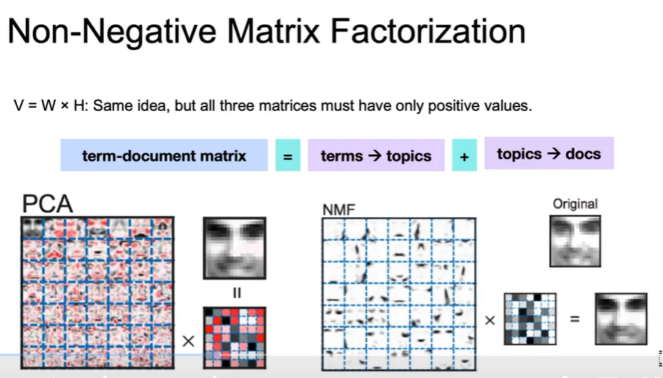
- NMF decomposes a matrix of positive values into two matrices, W and H, which also contain only positive values.
- It is particularly useful for datasets like word counts or images, where all values are non-negative.
Applications and Benefits of NMF
- NMF is effective in various fields such as text mining, image processing, and music analysis.
- The additive nature of NMF allows for more interpretable features, as components can be combined to recreate original data without negative values.
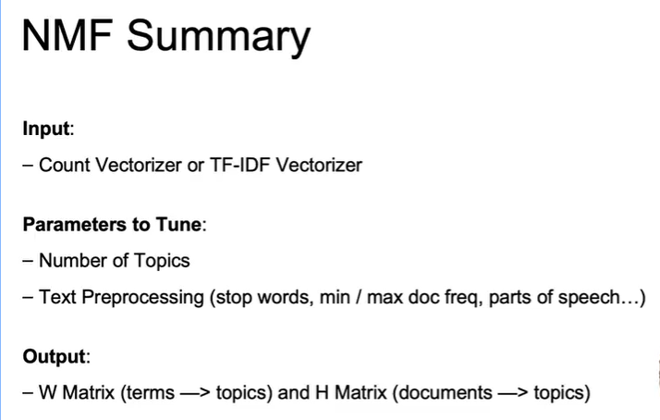
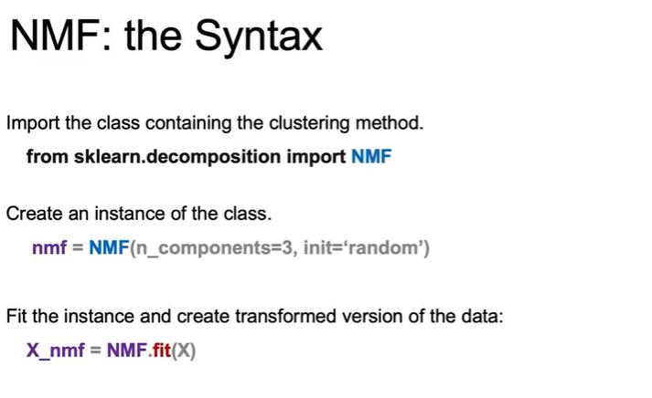
Comparison with Other Dimensionality Reduction Techniques
- Unlike PCA, which can lose interpretability due to negative values, NMF maintains a more intuitive representation.
- NMF can handle non-interpretable data objects and does not require orthogonal vectors, allowing for more flexibility in the decomposition process.
